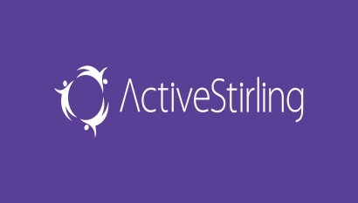



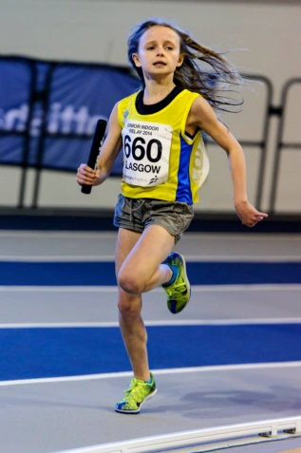
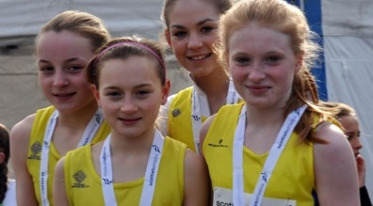
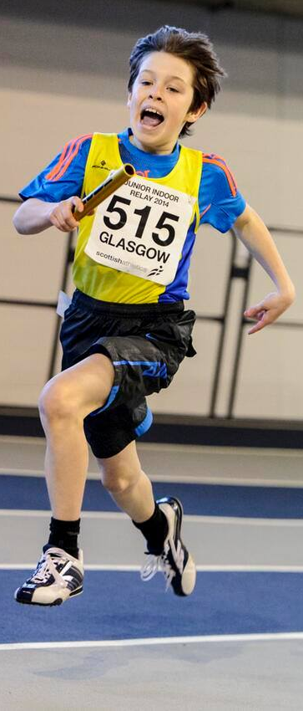
To attend the induction evening please contact Alison Grey, Athletics Development Officer (Active Stirling) on:
Tel no: 0300 028 0101
E-mail: greya@activestirling.org.uk

Central AC in partnership with Active Stirling are launching a brand new Satellite Athletics Club for children aged 9+
An induction evening will take place on Tuesday 27th October at the Mclaren Leisure Centre, Callander at 6.15pm followed by the club’s first training session!

Founded in 1974, Central Athletic Club is the premier athletic Club in Stirling and Clackmannanshire. With over 500 members, we are one of the largest Clubs in Scotland, and home to Scottish Champions, record holders and Internationalists.

Central Athletics Satellite Club

