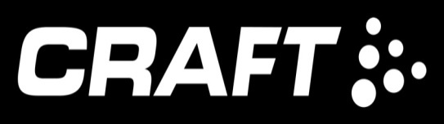

Trossachs Night Trail Series
Three Wednesday night trail races of 5 to 6 miles starting at 7pm
Race 1 – 2nd December, register at the Forth Inn, Aberfoyle
Race 2 – 27th January 2016, register at Wheels, Callander
Race 3 - 9th March, 2016, register at the Forth Inn, Aberfoyle
Each race will follow forest trails and fire roads in the Queen Elizabeth Forest Park, courses will be marked with reflective tape and head torches are mandatory. In the event of bad weather the race may be cancelled or the route changed.
Entry fee £5 for each race or £12 for the series of 3 races. Registration from 6pm.
To count in the overall series - 2 out of the 3 races must be completed. Prizes for overall series provided by 
Entry either on the day or pre enter on form
For further information http://carnethy.com/?p=13836 or contact Angela on 07765570503 or trossachstrails@mail.com
Facebook -https://www.facebook.com/trossachstrailrunning/info/
Event organised by Carnethy Hill Running Club. Entry forms available at www.carnethy.com
Carnethy Hill Running Club is a company limited by guarantee incorporated in Scotland with registered number SC492072 and having its registered office at 25a Stafford Street, Edinburgh, EH3 7BJ

