
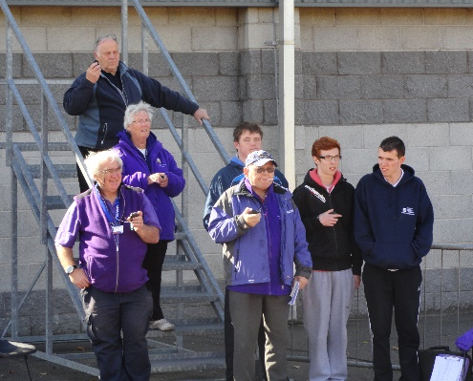



Cost: £30 for Officials Course.
FREE to Central AC members and family.
For bookings or more information, contact :-
shonamalcolm@scottishathletics.org.uk
or call on - 07731 832 567

scottishathletics Level 1 Officials
Timekeeping Course
Wednesday 12th July 2017
Stirling University Gannochy Sports Centre

What’s on?
12th July – Level 1 Timekeepers | 6pm - 9:30pm
Course Code – 17OFFL1TK04
No previous experience required
What’s involved?
These qualifications allow candidates to specialise in a single discipline as a timekeeper and work under the supervision of a qualified UKA Technical Official.

The courses consist of an introduction to officiating as well as the event specific module. The course is designed to help you recognise the specific qualities required to become a qualified Timekeeper.

The course will be delivered in both theoretical and practical elements covering:-
- Qualities and skills needed to be a good official
- Equipment required for a Timekeeper
- Communicating with athletes and other officials
- Positioning yourself for best viewing
- How to follow a duty sheet
- Understanding signs and signals
- How to interpret and apply the rules
- Ensuring safety and reporting concerns

